Camp Big Heart
P.O. Box 870150
Stone Mountain, GA 30087
Phone: 678-294-1916
Email: campbigheart@bellsouth.net
Web: www.campbigheart.com
For children and adults with developmental disabilities
Camp Blue Skies
Camp Blue Skies Foundation
1101 Queens Road West
Charlotte, NC 28207
Phone: 706-236-7902
Email: dick@campblueskies.org
Web: www.campblueskies.org
For adults with developmental disabilities
Camp ESP
Extra Special People
P.O. Box 615
Watkinsville, GA 30677
Phone: 706-769-9333
Email: laura@extraspecialpeople.com
Web: www.extraspecialpeople.com
For children and young adults with developmental disabilities
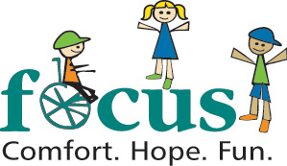 | Camp Infinity & Under the Stars Weekend  FOCUS  3825 Presidential Parkway, Suite 103  Atlanta, GA 30340  Phone: 770-234-9111  Email: inquiry@focus-ga.org  Web: www.focus-ga.org  Support for children and teens with disabilities and their families
Camp Inspire
Special Olympics Georgia
4000 DeKalb Technology Parkway
Bldg. 400, Suite 400
Atlanta, GA 30340
Phone: 229-834-3434
Email: robert.yost@specialolympicsga.org
Web: www.specialolympicsga.org
For individuals with intellectual disabilities
Camp Journey
Spectrum Clubs
P.O. Box 502
Grayson, GA 30017
Email: claidee@aol.com
Web: www.atlspectrum.org
For kids and young adults with autism and Asperger's Syndrome.
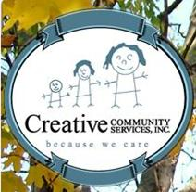 | Creative Community Services  4487 Park Drive, # A  Norcross, GA 30093-2964  Phone: (770) 469-6226  Email: info@ccsgeorgia.org  Web: www.ccsgeorgia.org/  For adults with developmental disabilities
Frazer Center
1815 S. Ponce de Leon Ave.
Atlanta, GA 30307
Phone: 404-377-3836
Email: a.price@frazercenter.org
Web: www.frazercenter.org
For adults with disabilities
Jewish Family and Career Services
4549 Chamblee Dunwoody Road
Atlanta, GA 30338
Phone: 770-677-9300
Email: info@jfcs-atlanta.org
Web: www.yourtoolsforliving.org
For adults with developmental disabilities
Just People
1420 Oakbrook Drive
Norcross, GA 30093
Phone: 770-411-1188
Email: amuller@justpeople.org
Web: www.justpeople.org
Support services to adults with developmental disabilities and mental illness
Laurel Heights
934 Briarcliff Road, NE
Atlanta, Georgia 30306
Phone: 404-888-7860
1-800-634-KIDS (5437)
Web: http://www.laurelheightshospital.com
For kids with autism
Learning on the Log
9 Dunwoody Park, Suite 133
Atlanta, GA 30328
Phone: 678-561-7589
Email: info@learningonthelog.com
Web: www.learningonthelog.com
For kids with sensory and/or developmental delays
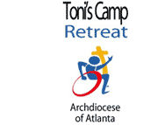 | Toni's Camp  Ministry with Persons with Disabilities  The Archdiocese of Atlanta  680 W. Peachtree St., NW  Atlanta, GA 30308  Phone: 404-888-7809  Email: emccoy@archatl.com  Web: www.archatl.com  An interfaith camp retreat for youths and adults with developmental disabilities
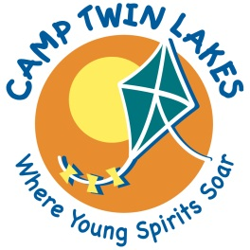 | Camp Twin Lakes: Will-A-Way  210 S. Broad Street  Unit 5  Winder, GA 30680  Phone: 770-867-6123  Web: http://www.camptwinlakes.org/locations/willaway.html  A fully accessible overnight camp in Fort Yargo.

